Team roles through padder tennis

Ākonga worksheet

Rules for our modified game of padder tennis | 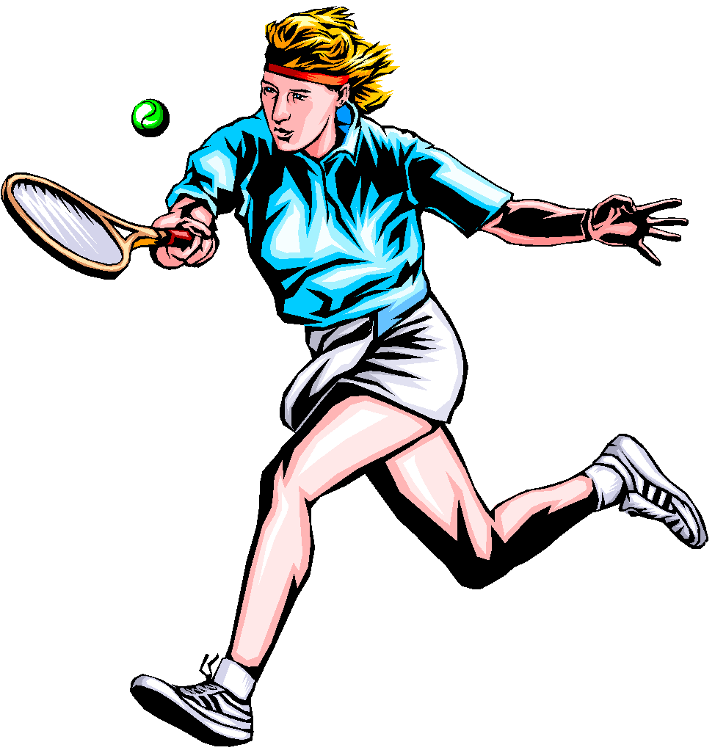
The skills needed to play our modified game of padder tennis | Some strategies needed to play our modified game of padder tennis

Ākonga recording sheet
Team roles through padder tennis

Roles in Sport
Captain
The captain’s responsibility is to …

Roles in Sport
Manager
The manager’s responsibility is to …

Roles in Sport
Player
The player’s responsibility is to …

Roles in Sport
Coach
The coach’s responsibility is to …

Ākonga recording sheet
Team roles through padder tennis
Code of Conduct
for all players of sport

